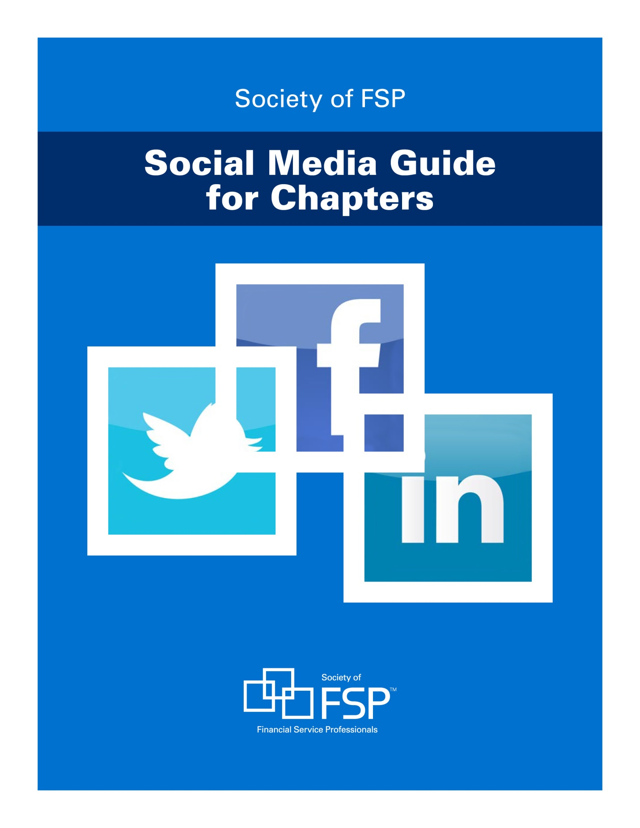

Society of Financial Service Professionals Social Media Guide for Chapters

Introduction 3
Basic Terminology & Definitions 3
General Terms 3
Twitter 4
Facebook 4
LinkedIn 5
Getting Started 5
Before Creating an Account 5
Creating Your Social Media Profiles 5
Maintaining Your Account 6
What Not to Post 6
Best Practices 6
Developing Your Strategy and Social Media Plan 6
Creating Your Profile 7
Tips for Succeeding with Social Media 7
Promoting Your Account 8
Twitter Tips 8
Who to Follow 8
Posting Guidelines 8
How to Compose a Good Tweet 9
Constructing a Tweet 9
Hashtags and Search Terms 9
Links and Images 9
Communicating Via DM and @ 9
Sample Tweets 10
Facebook Tips 11
Facebook Business Page vs. Facebook Group 11
Creating Your Business Page 11
Posting Guidelines 11
LinkedIn Tips 12
Why Do You Need a Company Page? 12
Resources 12

Society of Financial Service Professionals Social Media Guide for Chapters

Introduction

Social media has changed the way we communicate – both as an organization and as individuals. With tools such as Facebook, Twitter, YouTube, and blogs, anyone with an internet connection now has the ability to create a dynamic web presence, share their content instantly, and connect with people from around the world. Social media has given FSP the opportunity to engage with our members in real time about what is most important to them, extending our community found within our chapters to the world.

FSP supports the chapters’ use of social media to connect with members, fellow chapters, and others. This guide provides a basic overview of how to do so effectively. Social media is constantly changing and as a result, this guide will continue to evolve. If you have suggestions, please email socialmedia@societyoffsp.org.

Basic Terminology & Definitions

For a complete list, see Twitter’s Glossary and Facebook’s Glossary.

General Terms
Avatar Your profile image that appears next to all posts. Generally, this should be your logo. For logo files go to http://www.financialpro.org/chapter/sec/res_tools/ChapterFlyers.cfm

Profile A social media account created for personal or business use.
Feed This is the first thing you see when you log in to your social media account. New posts from profiles you follow appear in your feed.
Follower These are the people who have opted to follow your profile and can see your updates in their feed. You do not have to follow them in order for them to become your follower.

2

Twitter
@ Used to publicly reply to someone when placed at the front of the tweet or to mention someone when placed within or at the end of the tweet.
@username A username (or handle) is how you're identified on Twitter, and is always preceded immediately by the @ symbol. (example: @SocietyofFSP)
Hashtag (example: #POTUS or #FinancialPro) A type of keyword used to tie your tweet to other tweets about the same topic. Hashtags can be used for serious purposes or subjective humorous commentary. When you click on a hashtag, you will see other tweets containing the same keyword or topic.
Retweet Reposting a tweet to your feed either by clicking Retweet underneath the original tweet (the tweet will appear exactly as it appears on your screen) or by manually copying and pasting, adding RT @personwhooriginallytweeted.

Facebook
Pages Facebook has several kinds of pages: individual pages, groups, and Business Pages. You should set up a Business Page for your organization. A Business Page is like an individual’s page, where you can publish information, photos, videos, events, and content to the News Feed. Group pages will not publish onto a News Feed.
Cover Photo The large background image that appears at the top of Facebook Pages. This should be the photo that represents your group, organization or location. A logo is not necessary here.
@ Unlike Twitter @ replies, Facebook only lets pages reply to other Business Pages and not individual accounts. When typing your post, the @ symbol will show a drop-down menu as you type from which you can select the Page you are mentioning. It will not automatically tag the person, so you must select the page from the drop down.
Like There are two ways to “like” content on Facebook. You can click “like” below the individual posts or you can click “like” on a Page. Liking an individual post will only let the poster know you liked it, but liking a Page is akin to “following” or subscribing to their posts. Use individual post likes to determine popular content and Page likes to see how many people are subscribing to your content.

3

LinkedIn
Company Page A place for businesses to include information about their business and create updates about their business and their industry.
Network Your connections which also includes the connections of your connections.
Influencers Key and influential people in your industry who can provide you with great content.

Getting Started

Before Creating an Account
- Study the available social media platforms and determine the best one(s) for your needs and resources. The best social media account is an active, informative one.

Creating Your Social Media Profiles
- Clearly brand the social media profile as Society of FSP using approved high-resolution images and logos.
- Please fully complete all forms and descriptions to provide full background information on the profile.
- Include a link to your chapter website homepage and national’s website at www.SocietyofFSP.org, if possible.
- Email the links to your new or updated social media profiles to socialmedia@societyoffsp.org so national can promote them. Request to join the FSP Social Media Facebook group at: https://www.facebook.com/groups/1866934450187956/
NOTE: You may only join this group from your personal Facebook profile, not your chapter’s page. (See page 10 for details.) Please email the above if you have any questions about joining the group or regarding privacy.
- Promote your profiles beyond the medium: Send a notice, provide a link to your profiles on your website, add a link to your email signature.
- Link to (or follow, like, etc.) national’s social media accounts on each platform and other related FSP groups.
  - The main SFSP social media platforms are:
Facebook - /SocietyofFSP (https://www.facebook.com/SocietyofFSP/)
Twitter - @SocietyofFSP (https://twitter.com/SocietyofFSP)

4
LinkedIn – Society of Financial Service Professionals (https://www.linkedin.com/company/society-of-financial-service-professionals)

Maintaining Your Account
- Post as often as appropriate for your chosen platforms. Twitter and Instagram can handle a high volume of content, Facebook and LinkedIn users tend to be more sensitive to over-posting. A general rule of thumb is 3-5 posts per week on Facebook, 1-3 posts per week on LinkedIn, and 2-3 posts per day on Twitter.
- Use helpful social media management tools like Buffer, Hootsuite, and Tweetdeck to ease your workload. Many of these tools are free for one Twitter profile and will allow you to schedule Tweets in advance and monitor engagement.
- Sometimes it doesn’t make sense to distribute content in the same format to all social media channels. Make sure your approach is thoughtful and effective.

What Not to Post
- Content that belongs on personal accounts.
- Information irrelevant to FSP.
- Use caution when posting pictures. Let people in photographs know that their image may be used on FSP social media.

Best Practices

Developing Your Strategy and Social Media Plan
National recommends that you develop a social media strategy prior to promoting your accounts. Here are a few things to consider to help develop your strategy and identify your goals for social media:
- What do you want to accomplish? Are you interested in driving traffic back to your website? Creating awareness about your chapter, FSP, or your events? Finding and sharing information valuable to your audience?
- Who is your target audience? Current members, potential new members, partner organizations?
- How will you measure success? Do you want a large number of followers, or would you prefer a small community with strong ties to your mission?
- Who will be responsible for posting to the account and how often?
- Can you develop a social media content calendar so you know what to post and when?
5

Creating Your Profile
- User pictures (or profile images) make your account look professional.
- Use approved high-resolution images, backgrounds, and FSP brand colors to be consistent with all other FSP outlets on the web. FSP logos are at http://www.financialpro.org/chapter/sec/res_tools/ChapterFlyers.cfm.
- A full bio helps your account appear in search results.
- Be sure to link to your webpage and national’s website (at www.SocietyofFSP.org) in your bio.

Tips for Succeeding with Social Media
- Post with purpose. Establish a list of clearly defined goals. Social media goals should include short-term items – like improving website traffic or increasing registration for an upcoming event –and long-term objectives – like growing membership. Defined goals will help you evaluate your social media success and pin down the best tactics along the way.
- Choose your channels wisely. Evaluate the social platforms to determine where your audience is and if it is the right channel to reach your goals. LinkedIn is widely considered the most relevant for professional associations. Facebook and Twitter are great channels for expanding the conversation about your organization. You may consider channels outside the big three. YouTube and Instagram are especially relevant if you’re trying to engage any of the demographics that gravitate toward them (younger professionals, women, mobile users).
- Leverage and promote existing content. If you are creating authoritative content for your stakeholders, prospects, and/or the general public, social media can help that work shine. In fact, success in social depends on translating your thought leadership into engaging dialogue. So start planning your editorial calendar with social promotion in mind (e.g., tweaking your titles, incorporating surveys, soliciting questions and member stories, which are inherently sharable).

- Aim for consistency. Social media use requires momentum. It takes time and effort to generate lasting results. The best tack, regardless of your specific goals, is to unify your social messaging and responses and post content in small, steady doses.
6

Promoting Your Account
Promote your account by alerting other accounts, friends, and colleagues via email or the social media platform itself.
- Provide links to your social media profiles in your email signature
- Provide links to your social media profiles on your webpage.
- Promote your social media profiles on your personal social accounts and encourage others to do so as well.
- Include a widget on your website with feeds from your Twitter and Facebook profiles, if possible.

Twitter Tips

Who to Follow
- Follow the influencers and thought leaders in your industry. There’s a good chance they’ll follow you back and retweet your content to their followers.
- Find national’s Twitter profile (@SocietyofFSP), other FSP chapter and member accounts.
- Use Twitter Lists to organize the people you follow. They’re a good resource and they allow you to sort through your stream as you follow more people.

Posting Guidelines
- Try not to post several tweets at once. You can use social media management tools like Tweetdeck or Buffer to schedule your tweets in advance and spread your content throughout the day or week.
- Consider the time of day you post. Posting during the heaviest usage times such as rush hours (morning and evening) and lunchtime hours will help you reach a wider audience.
- Twitter can handle a higher volume of content than other social media platforms so there’s room to repeat your messages a bit. Just make sure you rephrase them instead of copying and pasting the exact same text.
- If you’re posting something topical, do a search to see who else is talking about it and consider either following that person or organization or using their @theirusername to tell them you’re discussing that topic, too.

Remember: People will follow you if they think you’re a good source of interesting information.

How to Compose a Good Tweet

Constructing a Tweet
- Tweets are limited to 140 characters, including link.
- Tailor each tweet to the content. You can use the post headline as a starting point, but don’t rely on it too heavily.
- Your tweet should be a tease to lure people into clicking on your link. Pay extra attention to the first few words since that’s all most people read when skimming.
- Experiment with formatting. If you have a great, short quote, post that instead of the headline. Try reframing a headline as a question.
- Try not to use all of the 140 characters so people who retweet can add commentary (120 characters, including the link, is ideal).

Hashtags and Search Terms
- Use #hashtags that are part of a movement or to make a commentary. Search for ones relevant to your tweet.
- Don’t hashtag general words or terms within your tweet. Twitter will automatically find it as a search term.
- Do some searches of the content in your tweet prior to posting it to find any relevant hashtags.
- Do not feel compelled to include a hashtag in every tweet. If you do, keep it to one or two hashtags.

Links and Images
- Try to include a link in your tweet that directs people to the webpage with that content.
- Use a link-shortening service like bitly.com to save characters and track the click-through rate on your tweets.
- Try to upload photos directly to Twitter via the “attach a photo” button so that it shows up on your homepage sidebar.

Communicating Via DM and @
- DM (Direct Messages) are private, while RTs and @ mentions are public, so be aware of which you are composing.
- When possible, engage your followers.
  - Every once in a while, thank someone for retweeting.
  - If someone @ mentions or DM contacts you, reply as quick as possible.
- Do a bit of promotion for others, and they’ll return the favor.
  - See an interesting tweet? Retweet it. Ideally, you’ll add a bit of commentary when you do so. 8

Sample Tweets

Below are several examples of tweets that demonstrate how to use shortened links, hashtags, and @ mentions to promote your organization and your events.

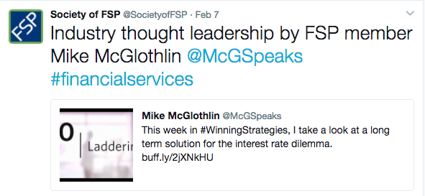9

Facebook Tips

A Facebook page can be a great way to promote the activities of your chapter, showcase accomplishments and events, engage with followers, and create a sense of community and a forum for conversation and discussion.

Facebook Business Page vs. Facebook Group
It is recommended that you create a Facebook Business Page, rather than a Facebook Group for your organization. The chart below, compares the features offered by Pages vs Groups.
Feature | Business Page | Group
Allows personalized URLs | Yes | No
Appears in search engine results | Yes | No
Page Admin can access visitor statistics and analytics | Yes | No
Discussion features and forums | Yes | Yes
Cross-promotion via @ mentions on other pages | Yes | Yes
Create events and send invitations | Yes | Yes
Twitter or blog feed integration | Yes | No
Visible to people who do not follow you | Yes | No
Followers can leave comments and “likes” | Yes | Yes
Send out bulk emails to your followers inboxes | No | Yes
Publish content to the News Feed | Yes | No
Hide administrator’s personal account information | Yes | No

Creating Your Business Page
- To create a Business page, you will need to have a personal Facebook account that will be linked to the Business page.
- Go to www.facebook.com/pages/create.php to create your Business page.
  - Choose either “Local Business/Place” or “Company, Organization, Institution”
  - Fill out all descriptions and fields including your website URL and business contact information.
  - Make sure you have an avatar/profile image (preferably your logo) and cover photo. Using the hero image from your homepage will reinforce branding.

Posting Guidelines
- Avoid publishing too many updates to your followers (2-3 posts per week is fine)
- Mention when your website is updated, whether it’s new articles, videos, an upcoming event, etc. 10
- Monitor comments on your Facebook page daily and respond to those that warrant it.
- Ask others to share your content and to like your Facebook page.
- Utilize links to relevant web pages on your posts. Use a link shortening service like bitly.com to save characters and track click-through rates.
- Keep posts under 420 characters. Facebook will hide anything over that limit.

LinkedIn Tips

While LinkedIn may not attract as much attention as Facebook or Twitter, it is definitely still worth considering because it’s the social network for professionals, without the games and distractions of many other networks.

Why Do You Need a Company Page?
Reach. Without putting any efforts into building your organization on LinkedIn, chances are many of your members are updating their personal profiles to show their affiliation with your organization. Every person that connects with that member’s profile may potentially click on your organization’s name and be navigated to your Company Page. Take advantage of this. Many users can easily land on your page through simple LinkedIn browsing. Opinions will be formed based on the amount and type of information displayed so it is important to build out our company page with updated information.

- Post status updates about important FSP news, chapter events, and member accomplishments.
- Utilize LinkedIn’s Publisher platform (a built-in blogging tool) to write an article or blog post relevant to your followers.

Resources

- FSP logos for the various platforms -http://www.financialpro.org/chapter/sec/res_tools/ChapterFlyers.cfm
- Facebook Help Center - https://www.facebook.com/help/
- Twitter Help Center - https://support.twitter.com/
- LinkedIn Help Center - https://www.linkedin.com/help/linkedin
- How to Create a Facebook Business Page in Five Simple Steps [Tutorial]- https://blog.hubspot.com/blog/tabid/6307/bid/5492/How-to-Create-a-Facebook-Business-Page-in-5-Simple-Steps-With-Video
11
- How to Create a LinkedIn Company Page to Promote Your Business-http://www.socialmediaexaminer.com/create-a-linkedin-company-page-to-promote-your-business/
- How to Setup a Twitter Business Account in 3 Easy Steps – https://blog.hubspot.com/blog/tabid/6307/bid/5950/How-to-Setup-a-Twitter-Business-Account-in-3-Easy-Steps-Video.aspx
- FSP Social Media Facebook group at: https://www.facebook.com/groups/1866934450187956/
This is a Facebook group page for chapter leaders and members managing or providing content for FSP chapter social media channels including Facebook, Twitter, LinkedIn, or any platforms not discussed in this guide. This is an open group to pose questions, post articles or topics related to social media and the financial service industry, and to share any posts that might be of interest to the larger FSP community that national or other chapters could share on social media.

For questions regarding these social media guidelines, please e-mail socialmedia@societyoffsp.org.

12

